**Digital Twin and 2D/3D Visualisation**

**Partner site:** Digital Engineering Lab Cranfield University | **Main scenario:**  Maintenance, Manufacturing



Available Sensors & VISUALISATION TECHNOLOGIES

* Camera, computer sensors, and a range of physical properties measuring sensors such as vibration sensor, proximity sensor, temperature and humidity sensor, etc.
* (1) Mixed reality headsets; Hololens 2 and Magic leap, (2) Dekstop-based and handheld devices

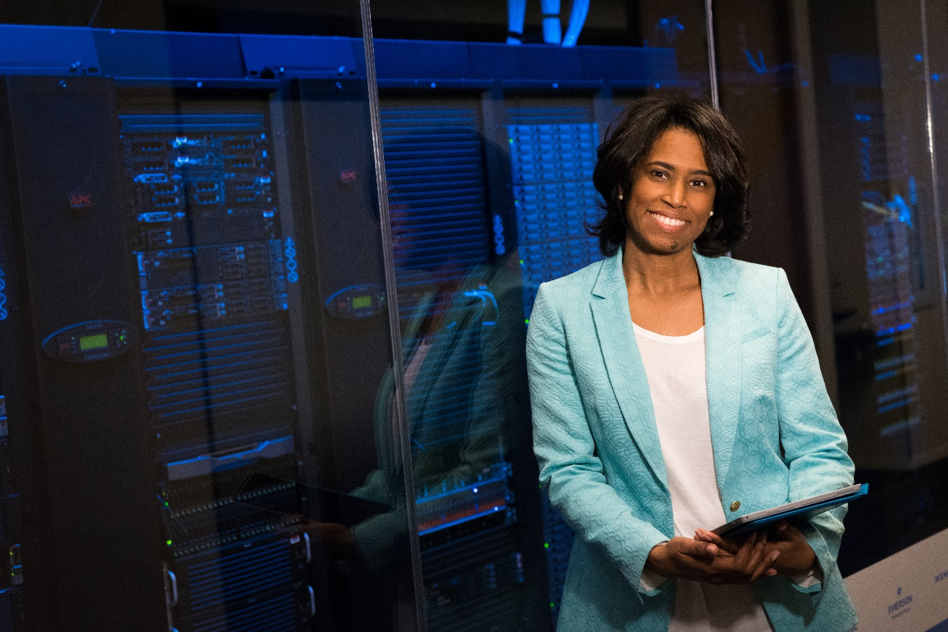



Valentina

Shilpa

**3D visualisation**

**2D Desktop visualisation**

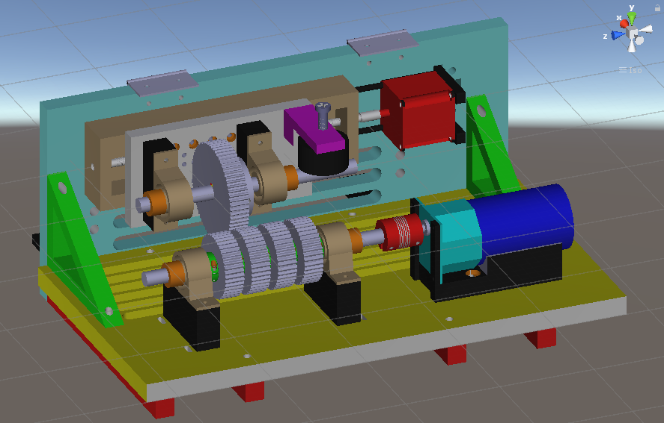

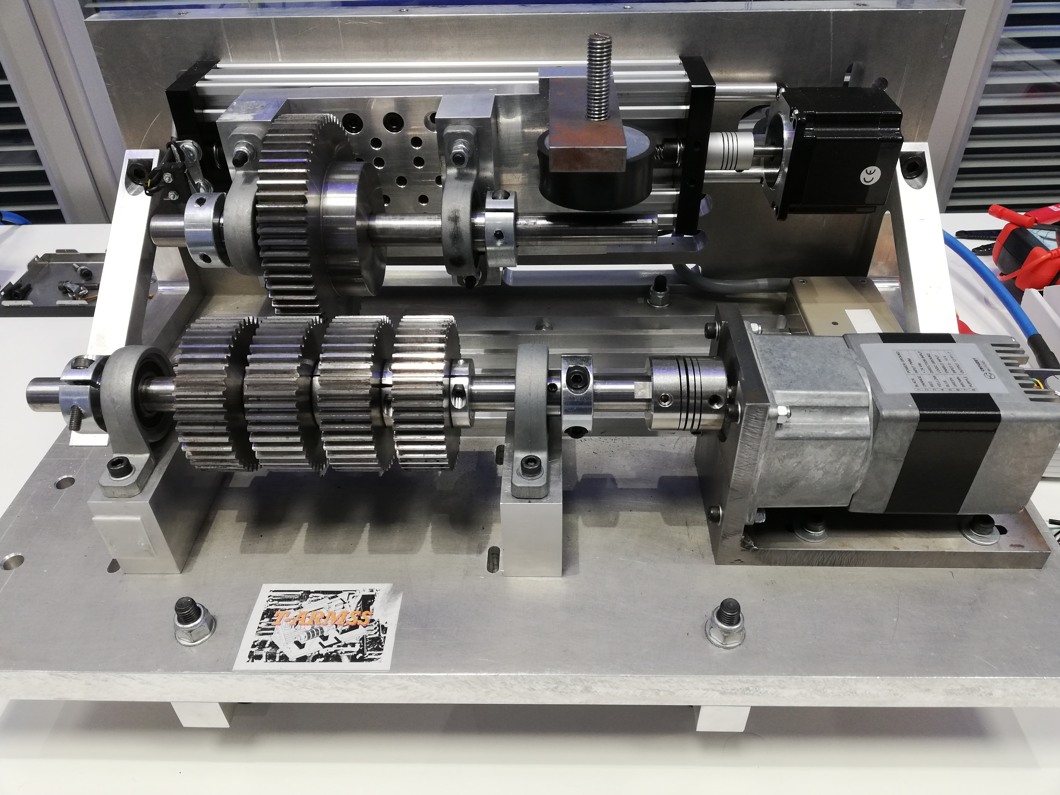

Connectivity + supported Software

* Data logging from sensors are managed by Arduino Yun and Raspberry PI transmitting to the local/cloud database through a web server
* 2D/3D visualisation application is developed with Unity and data communication between Unity application and a database server is handled via HTTP request and TCP/UDP socket

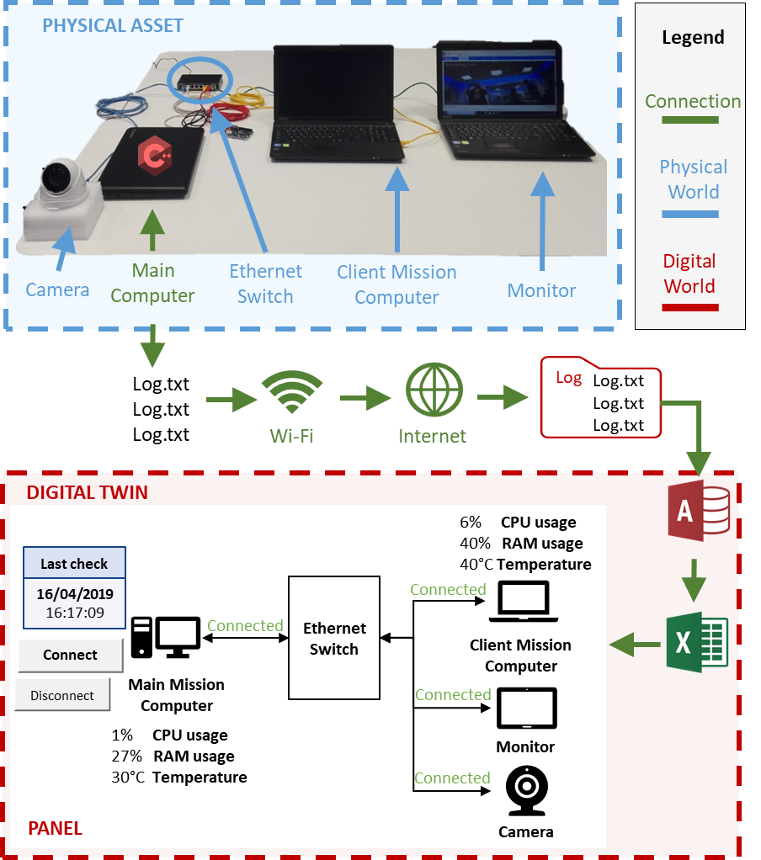

**DRAFT**

Related Digitop personas

ABOUT

Modular framework was designed to facilitate the creation of Digital Twin (DT) regardless of types of products, processes, services. A set of demonstrators includes condition monitoring of gearbox, operation of robot, and monitoring of computer networking system embedded in helicopter using this framework is being validated. To maximise the benefits of DT, desktop-based visualisation and Augmented Reality (AR) are being investigated to enhance the capability of DT in maintenance and manufacturing applications. Moreover, subjective and objective human data are incorporated to add context-aware capabilities to DT system.